41

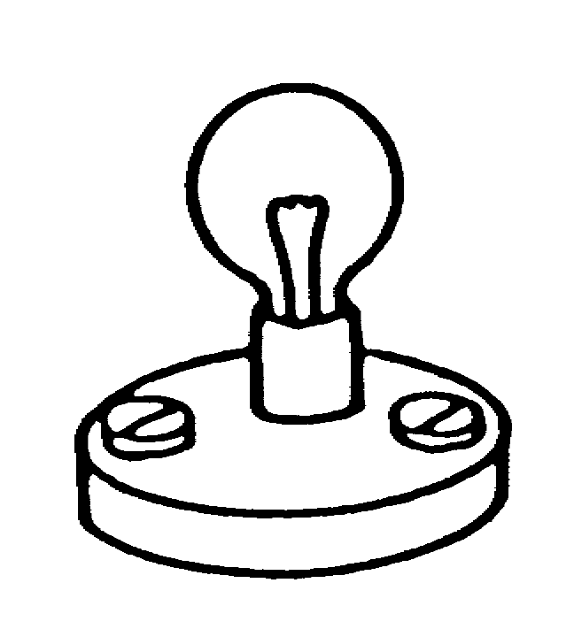
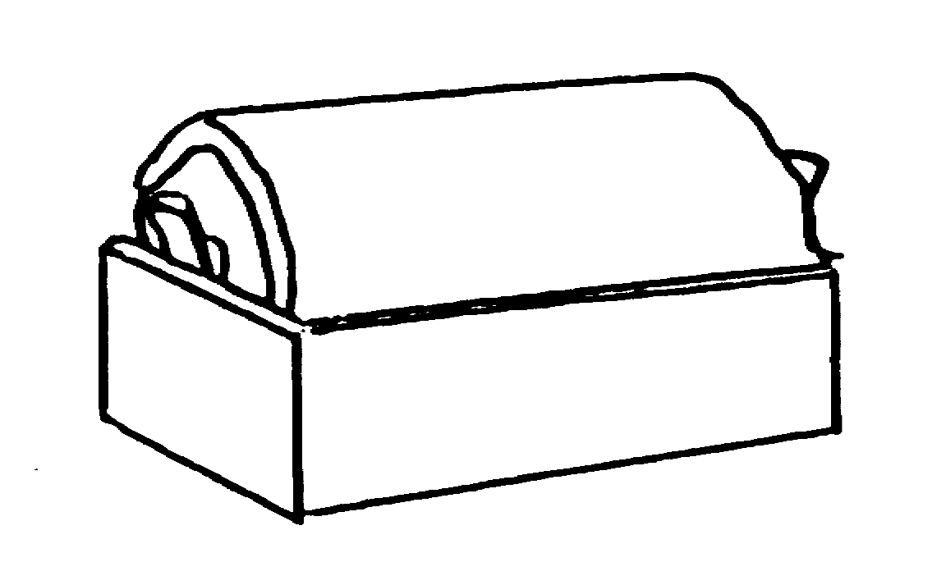
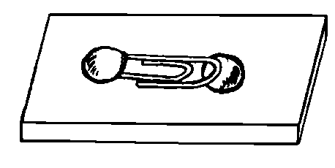
In this circuit both bulbs are lit.
bulb 1
bulb 2

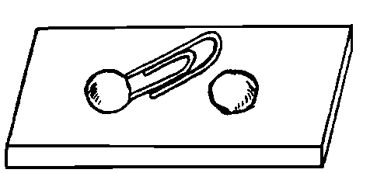
bulb 2
The switch is now opened.

bulb 1

(a) What do you think will happen?

Tick ONE box ()

❑ | Both bulbs will stay lit.
❑ | Bulb 1 will stay lit. Bulb 2 will go out.
❑ | Bulb 1 will go out. Bulb 2 will stay lit.
❑ | Both bulbs will go out.

(b) How would you explain this?

Tick ONE box ()

❑ | The switch only affects the bulb that comes after it.
❑ | Both bulbs are still connected to the battery.
❑ | The circuit is broken so there is no current anywhere.

